Ohio State Chiropractic Association
172 E State Street, Ste 502, Columbus, OH 43215
(614) 229-5290 (p) ~ (614) 229-5296 (f)
Date of Evaluation: __________________________ Patient Evaluation □ Initial □ Update □ Exacerbation □ Progress #: ______
Patient: ___________________________________________ Patient #:________________________ | Patient Category  ________________ | Date of Injury  ________________

Visual Postural Analysis
L R
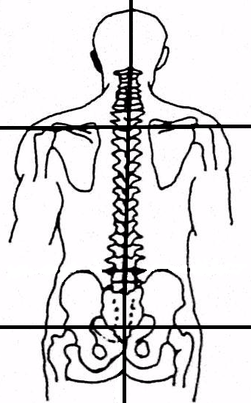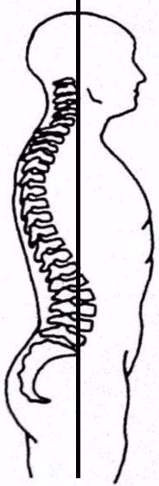

Deep Tendon Reflexes | None | Hypo | Normal | Hyper
Biceps (C5) Right | 0 | +1 | +2 | +3
Left | 0 | +1 | +2 | +3
Triceps (C6) Right | 0 | +1 | +2 | +3
Left | 0 | +1 | +2 | +3
Radialis (C7) Right | 0 | +1 | +2 | +3
Left | 0 | +1 | +2 | +3
Patellar (L4-L5) Right | 0 | +1 | +2 | +3
Left | 0 | +1 | +2 | +3
Achilles (L5-S1) Right | 0 | +1 | +2 | +3
Left | 0 | +1 | +2 | +3

Other
Heart Rate ______________ bpm.

Blood Pressure _______/_______

Height _________________ ft/ in.

Weight __________________ lbs.

Key: =Restricted Motion =Misalignment =Muscle Tension/Spasm
Discomfort: 1=slight 2=mild 3=moderate 4=severe S=Swelling/Inflammation X=Trigger Points
L Palpation R  O | 1  2  3  4  5  6  7 | 1  2  3  4  5  6  7  8  9  10  11  12 | 1  2  3  4  5 | S | IL

Cervical ROM | Degrees | D (1-4) | Remarks: | Dorsolumbar ROM | Degrees | D (1-4) | Remarks:
Flexion (45) |  |  |  | Flexion (60)
Extension (45) |  |  |  | Extension (30)
R. Lateral Flex (45) |  |  |  | R. Lateral Flex (30)
L. Lateral Flex (45) |  |  |  | L. Lateral Flex (30)
Left Rotation (80) |  |  |  | Left Rotation (30)
Right Rotation (80) |  |  |  | Right Rotation (30)

OrthoNeuro Tests | L | R | Remarks: | Extremity ROM | L | R | Remarks:
George’s Test |  |  |  | TMJ Findings
Rib Humping |  |  |  | Shoulders
Valsalva’s |  |  |  | Elbows
Balance Test |  |  |  | Wrists / Hands / Fingers
Proprioception Test |  |  |  | Internal Femoral Rotation
Meningeal Spinal Tension |  |  |  | External Femoral Rotation
Foraminal Compression |  |  |  | Knees
Shoulder Depressor |  |  |  | Ankles / Feet / Toes
Scheppleman’s |  |  |  | Muscle Tests | L | R | Remarks: 0, 1, 2, 3, 4, 5
Kemp’s |  |  |  | Shoulder Abduction
Thoracic Outlet Findings |  |  |  | Shoulder Flexion
Laseque’s |  |  |  | Shoulder Lateral Rotation
Short Leg |  |  |  | Hip Flexion
Anterior Rib Tenderness |  |  |  | Hip Abduction

Dr.’s Signature_____________________________________________________________________ Date__________________________

